ACTIVITY RELEASE OF LIABILITY
READ CAREFULLY - THIS AFFECTS YOUR LEGAL RIGHTS
In exchange for participation in the activity of Haiti Mission Trip organized by Cabaret Haiti Mission ("CHM"), of 2700 University Blvd. S., Jacksonville, Florida 32216, and/or use of the property, facilities and services of CHM, I agree for myself and (if applicable) for the members of my family, to the following:
1. I agree to observe and obey all posted rules and warnings, and further agree to follow any oral instructions or directions given by CHM, or the employees, representatives of CHM.
2. I recognize that there are certain inherent risks associated with the above described activity, and I assume full responsibility for personal injury to myself and (if applicable) my family members, and further release and discharge CHM for injury, loss or damage arising out of my (or my family's) use of or presence upon the facilities of CHM, whether caused by the fault of myself, my family, CHM or other third parties.
3. I agree to indemnify and defend CHM against all claims, causes of action, damages,
judgments, costs or expenses, including attorney fees and other litigation costs, which may in any way arise from my or my family's use of or presence upon the facilities of CHM.
4. I agree to pay for all damages to the facilities of CHM caused by my or my family's negligent, reckless, or willful actions.
5. Any legal or equitable claim that may arise from participation in the above shall be resolved under Florida law.
I HAVE READ THIS DOCUMENT AND UNDERSTAND IT. I FURTHER
UNDERSTAND THAT BY SIGNING THIS RELEASE, I VOLUNTARY
SURRENDER CERTAIN LEGAL RIGHTS
Dated: _______________
Signature: _______________________________________
(If under age 18, signature of parent or guardian)
Printed Name of Participant: ______________________________________
Address: ________________________________________________________
__________________________, _______________ _______________
In case of an emergency, please call _____________________ (Relationship: ________) at __________________ (Day), or ________________ (Evening).

© This is a RocketLawyer.com Legal Document ©

Cabaret Haiti Mission, Inc.

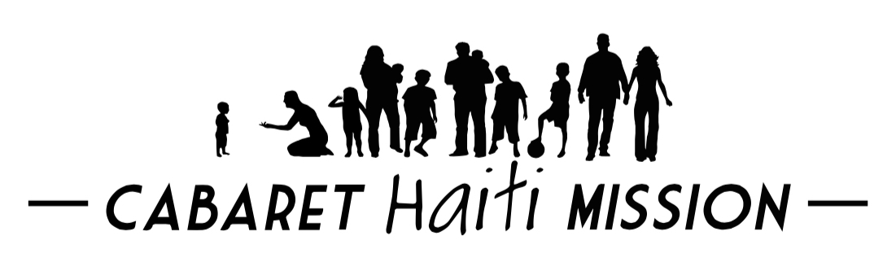

MISSION TRIP APPLICATION

Mission Trip Dates: ___/___/___ to ___/___/___

Cabaret Haiti Mission
2700 University Blvd. S.
Jacksonville, FL 32216-2557

Passport Name __________________, _________________ ____________________
Last First Middle

Address _____________________________________________________________________
Street City State Zip Code

Home Phone ( )_____________ Work Phone ( ) ____________ Fax( ) _____________
Cell phone ( ) _____________ E-mail __________________ Date of Birth ___/___/___
Church Membership

___________________________________________________________________________
Church Name Address City State Zip Code
Emergency Contact __________________________________________________________
Name Relationship Phone

Beneficiary _________________________________________________________________
Name Relationship Phone

Have you been on a mission trip? Y N Date ____________ Location ________________
(use back if needed)
Have you been to Haiti before? Y N Date ____________
Do you have a passport? Y N Expiration Date ___/___/___
Passport Number ____________________________
Have you had the following immunizations?
Hepatitis A Y N Date ____________
Hepatitis B Y N Date ____________
Malaria Y N Date ____________
Typhoid Y N Date ____________
Tetanus Y N Date ____________

What is your occupation? ________________ Physical Limitations? _____________________
What talents, skills or abilities do you possess that can be used on a mission trip to Haiti?
______________________________________________________________________________
Please write a brief paragraph of your spiritual journey below or on the back of this application.

